Certificate of Analysis

General properties:
Name： FA-PEG3400-Alkyne
Molecular Weight： 3400 Dalton
Cat.#：R-9953
Lot.#：RFA201604025
Manufacture Date： 2016.04.25
Date of Analysis： 2016.04.25
Recommended Retest date： 2017.04.25
Stability： 12 months
Storage： -20°C in the dark

Structure

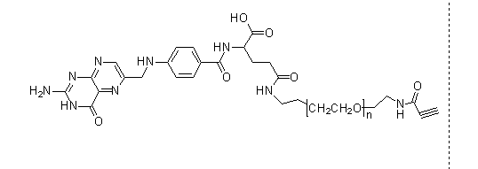

Items | Specification | Results
Appearance | Yellow/ Light yellow solid | Yellow solid
¹H NMR | Identical to the Structure | Identical to the Structure
Foreign Material | None | None
Purity | ＞90% | 90%
Report Date: 2016.04.25

This product is for research use only, Not for human or animal use

